Web Development 1: Midterm Project

Team Name: Team 3

Team Members: Kevin Munoz, Muhammad S Rehman

Screen-shots of Web Page 1 in browser

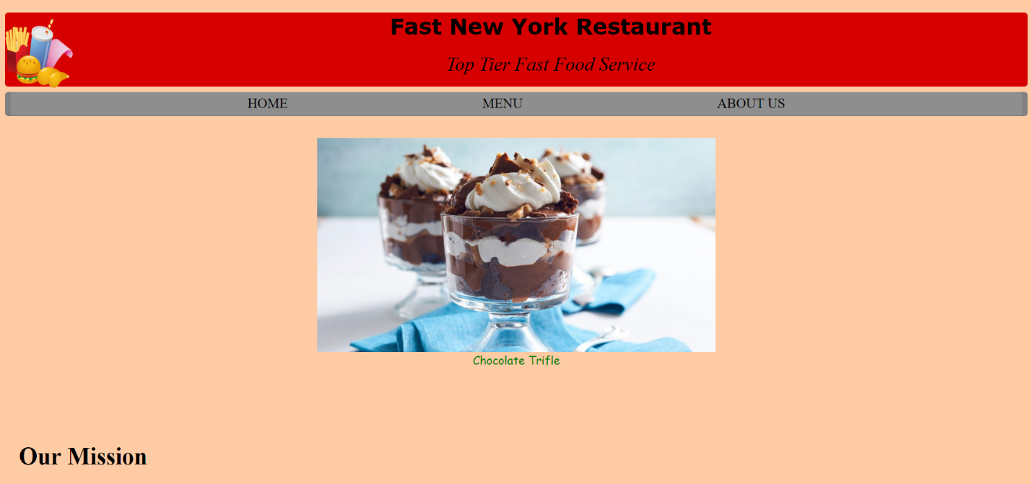

Screen-shots of Web Page 1 in Notepad++

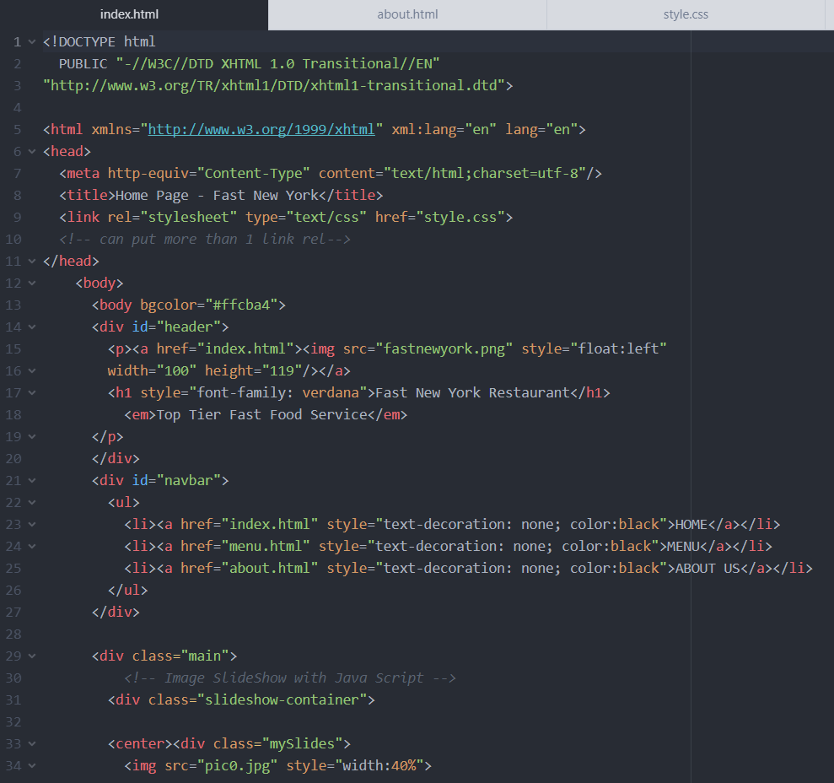

Screen-shots of Web Page 2 in browser

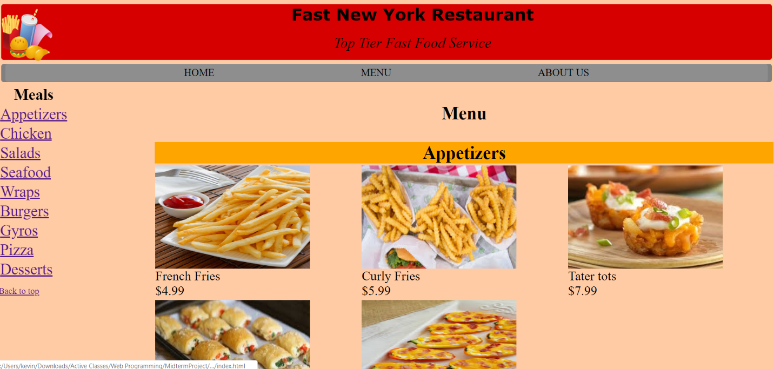

Screen-shots of Web Page 2 in Notepad++

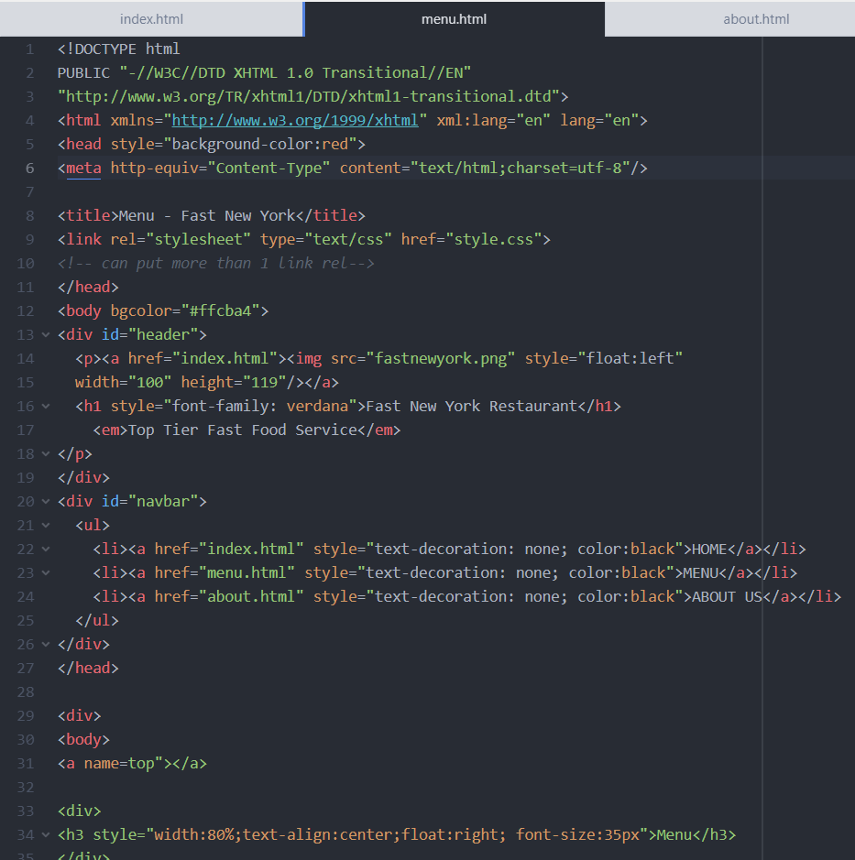

Screen-shots of Web Page 3 in browser

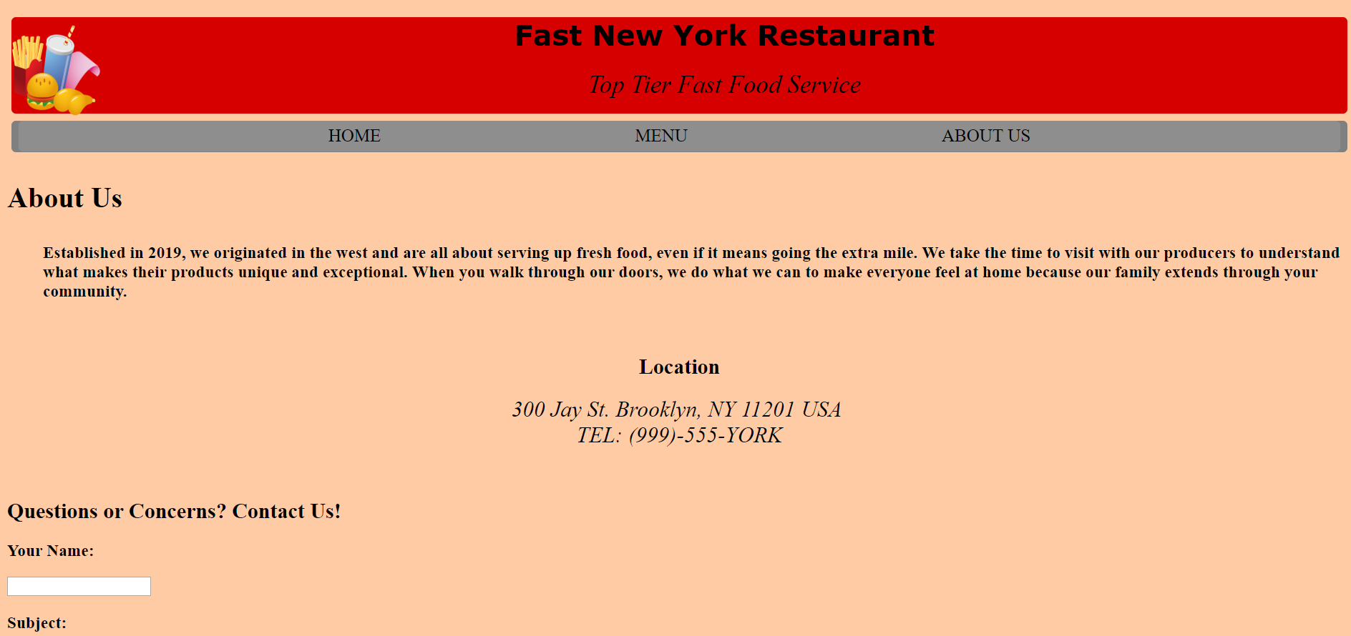

Screen-shots of Web Page 3 in Notepad++

